**Policy Center**

**Test environment:**

URL for choosing Test Environment,

[https://adt.qbe.com](https://adt.qbe.com/)

Path for choosing Environment (Eg: ST, SIT, UAT),

Applications 🡪Guidewire 🡪Choose environment (from right hand side window)

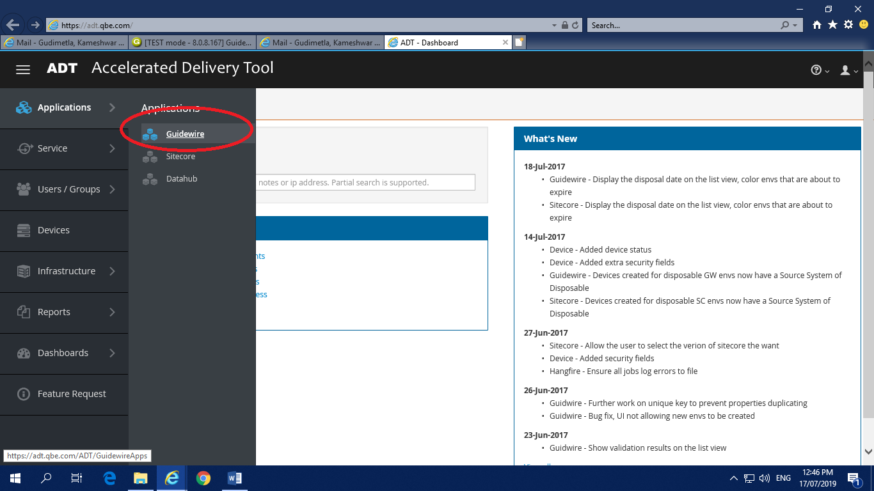

**SIT URL** for policy center,

<https://sit1-gw/PC>

**Note: L**ogin in to the policy center using Super User credentials and create a Single Sign in user to proceed with policy creation and other transactions.

Credential for Super User

Username: **su**  Password: **gw**

**New User Creation:**

Follow the below steps to create new user

Go to **Administration 🡪 User & Security 🡪 User**.

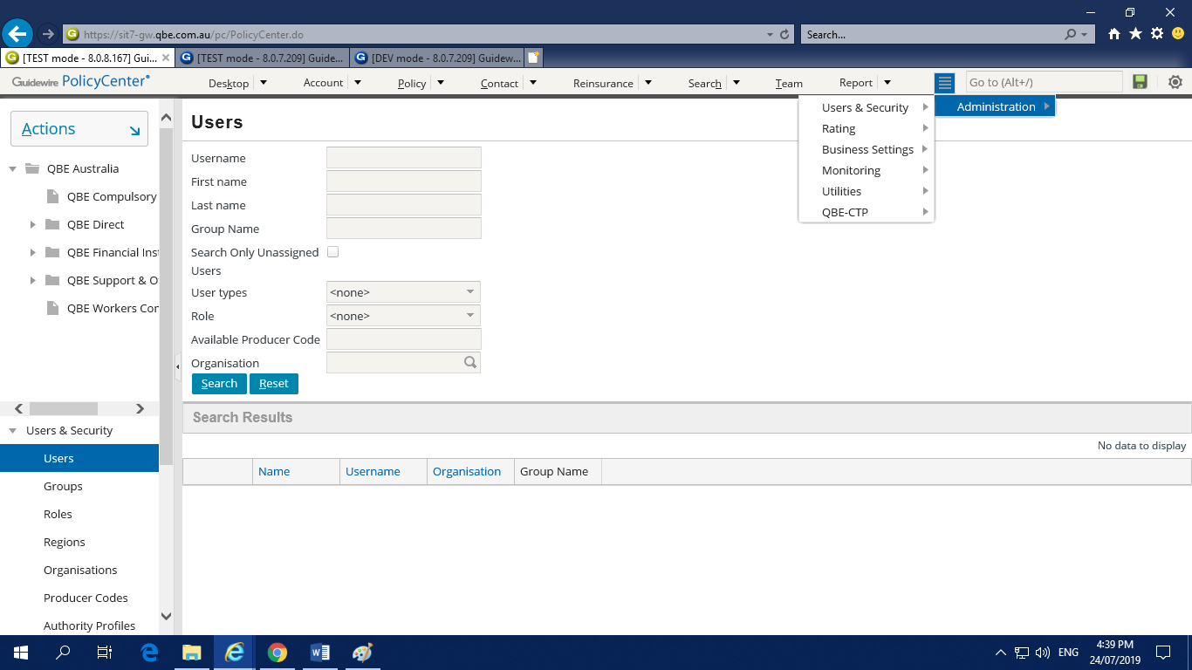

And then go to **Actions 🡪 New User**

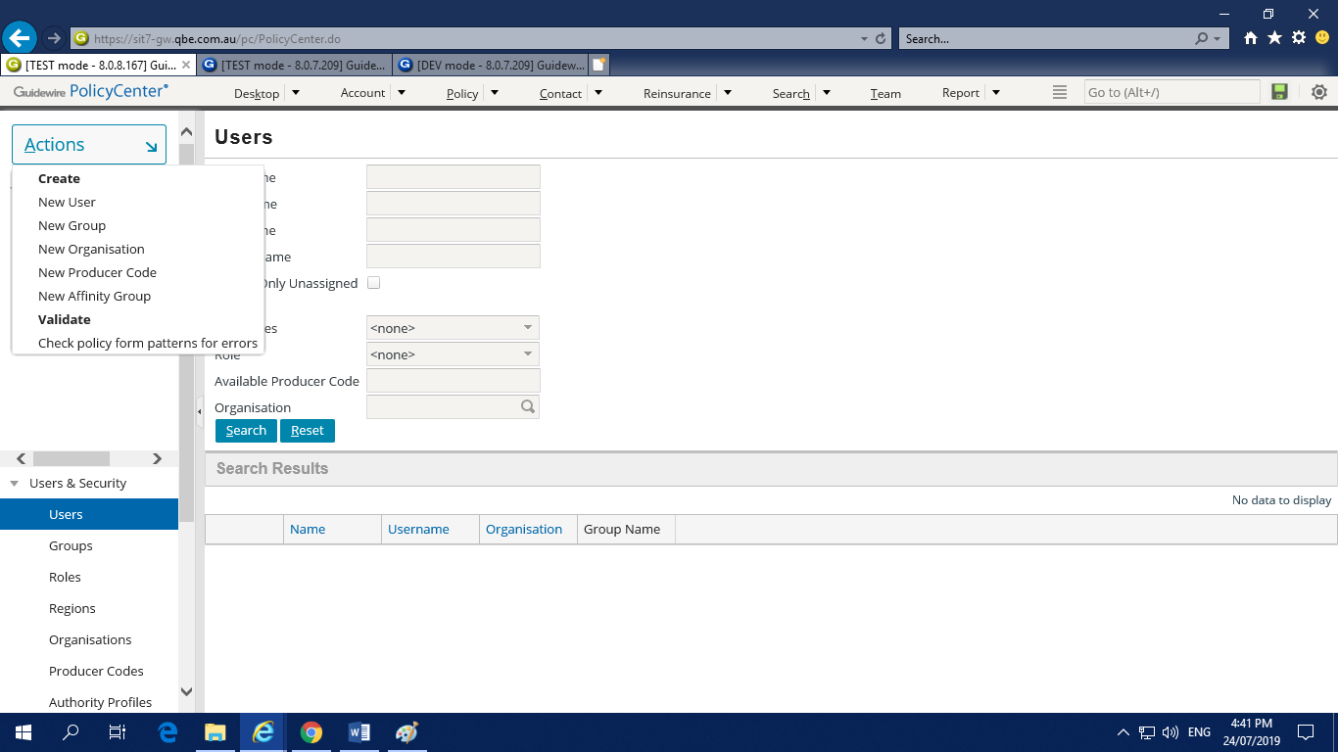

Fill all the details in the Basics page and go to Roles page by clicking on Roles

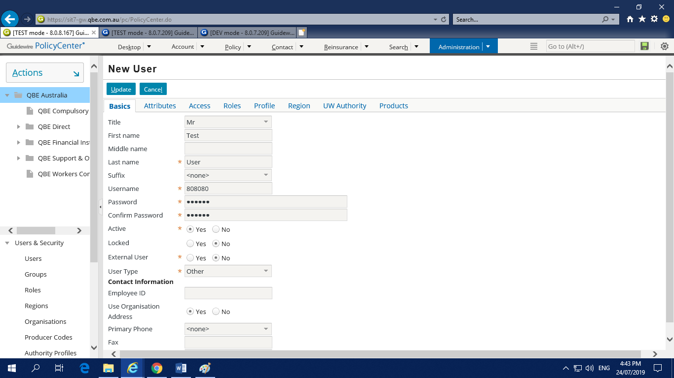

Add some roles and click on Update, new user will be created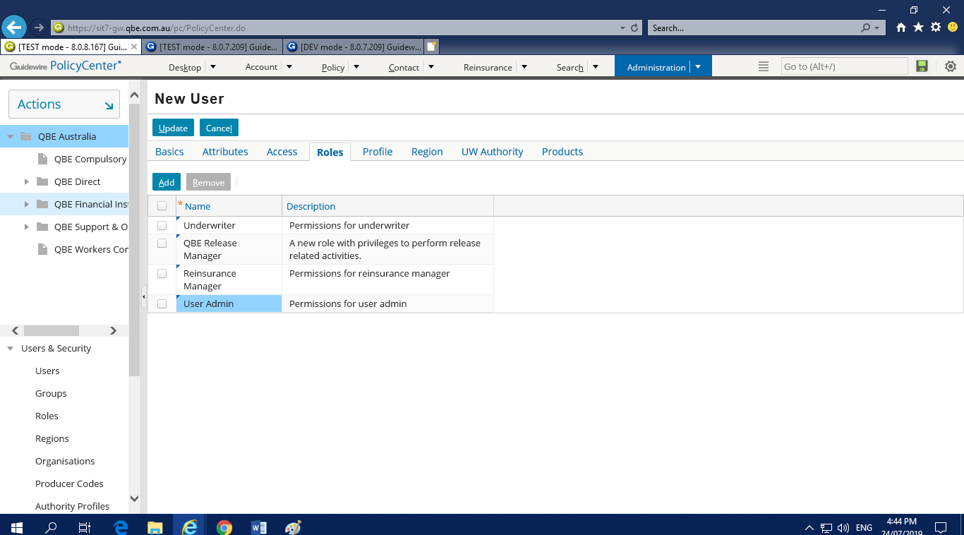

In the policy center we have following transactions to perform

* Contact Creation
* Policy Creation
* Policy Renewal
* Change Policy
* Cancel Policy
* Reinstatement
* Rewrite

**Contact Creation:**

In Order to create a policy first we have to create a new contact or open an existing contact.

**Step 1:**

Go to the **Contact** in Navigation bar and then select **Search** option in the drop-down list

Contact 🡪 Search

You will get a page to search for the contact

**Step 2:**

Enter the First Name and Last Name and then click on **Search** button.

**Note:** Both First name and Last name are mandatory for search. Otherwise You will get an error message.

If there are any existing contacts with that name, it will display the contacts with that details or else it will show as “The search returned zero results.” And we will get button beside Print/Export with name **Add New Person**.

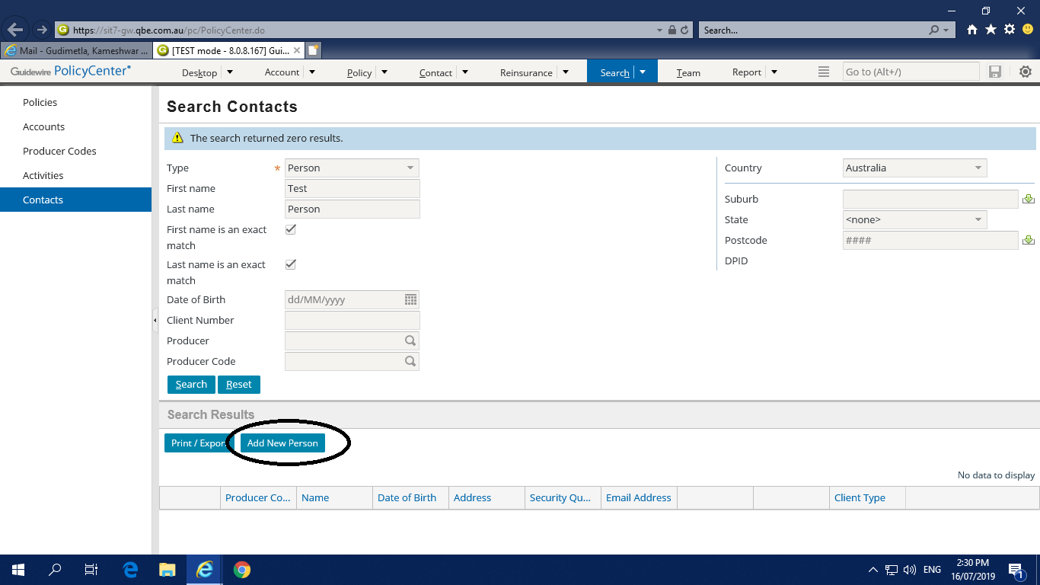

**Step 3:**

Click on the **Add New Person** Button, we will get a page for contact creation.

**Step 4:**

Fill all the mandatory fields and also the Email and Mobile No fields, those are not mandatory but later on required to the create policy

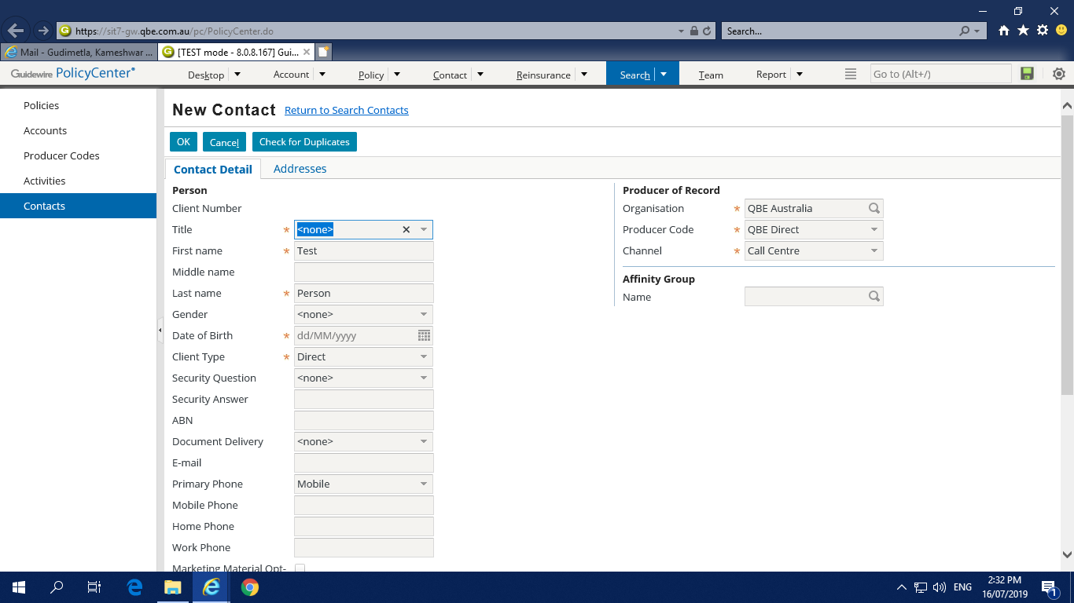

**Note:** In the Address field type up to six digits and the system will suggest the address stored in it. Select one of them, automatically all the address fields will be populated.

After all the required fields are filled Click on the **OK** button on the top left of that page then the Contact will be created successfully and displays the Conatct File Details page.

**New Policy Creation:**

In order to create a policy, open a contact or create a new contact by following the above procedure.

**Step 1:**

Navigate to Accounts Option 🡪 click Create Submission button

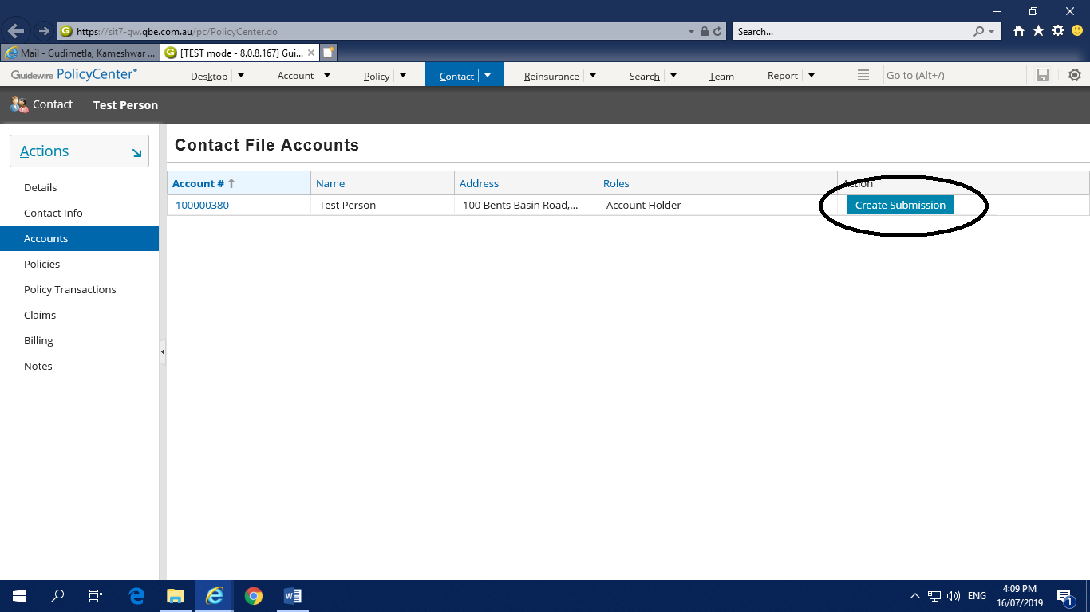

**Step 2:**

In Create Submission page, select Quote type as Full Application & Date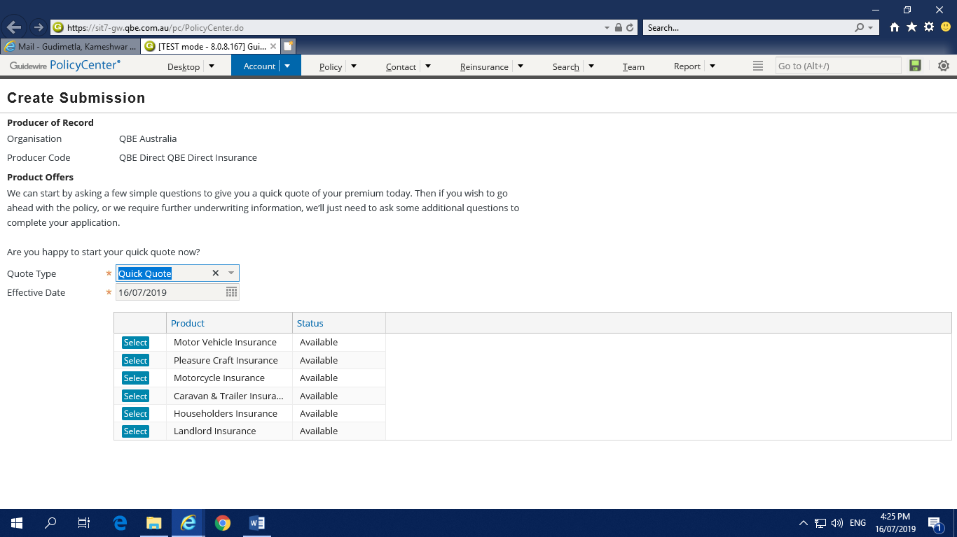 and select any one of the product by clicking Select button.

The procedure for all the products is same but the details required for the policy creation changes with the product.

**Step 4:**

In Pre-Qualification Quick quote page, it asks as some questions, choose Yes for all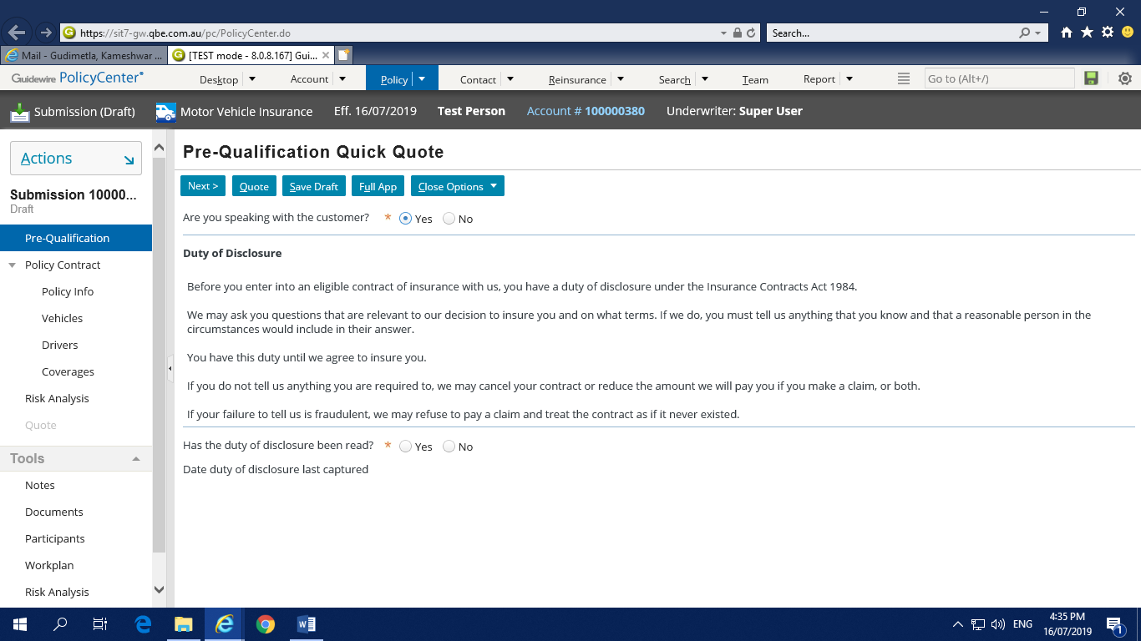.

**Step 5:**

Policy Info page will have information about the communication & policy term. Fill all the mandatory fields & click NEXT

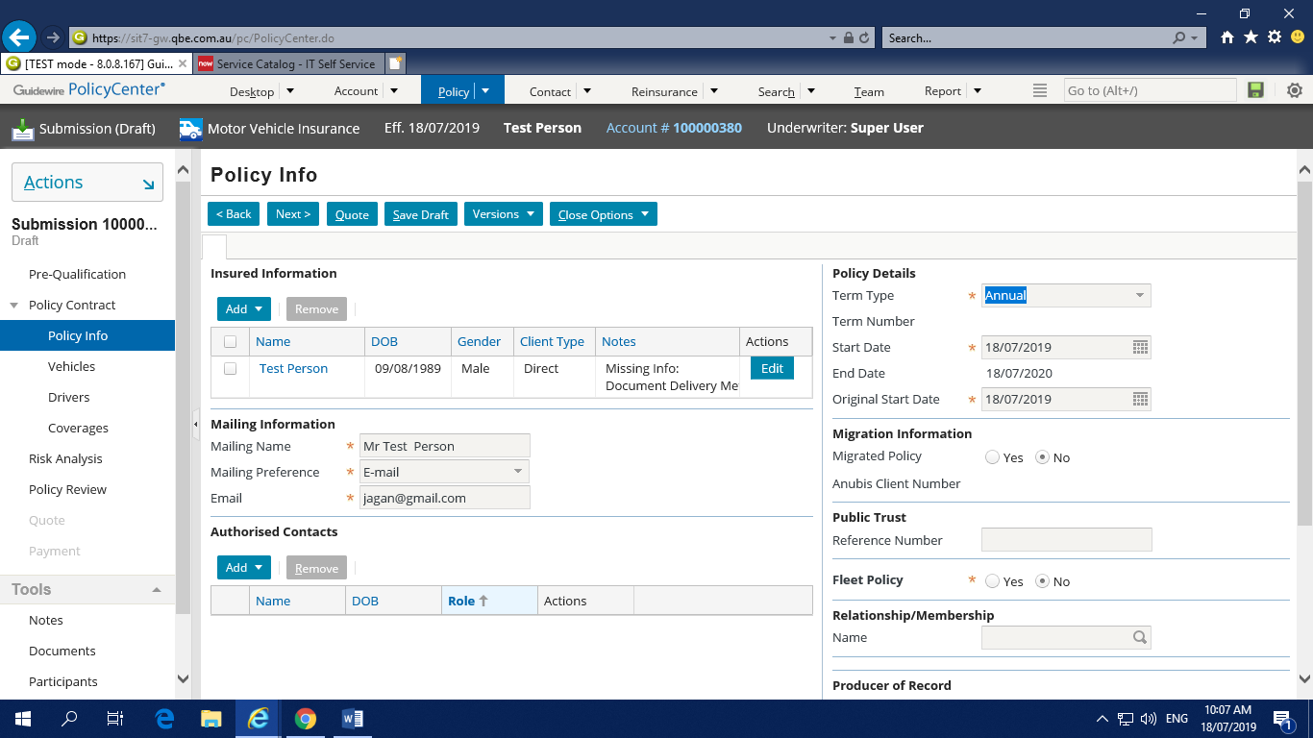

**Step 6:**

Vehicles page will have the details about the vehicle. Here we can add number of vehicles by clicking ADD Vehicle button. We can choose the vehicle by Registration Search or Vehicle Search option.

**Vehicle Search Option**

Fill out the vehicle search mandatory fields & click **Vehicle** **Search** button to get the list of vehicles. Choose any vehicle from the list with corresponding mandatory fields & click Ok button.

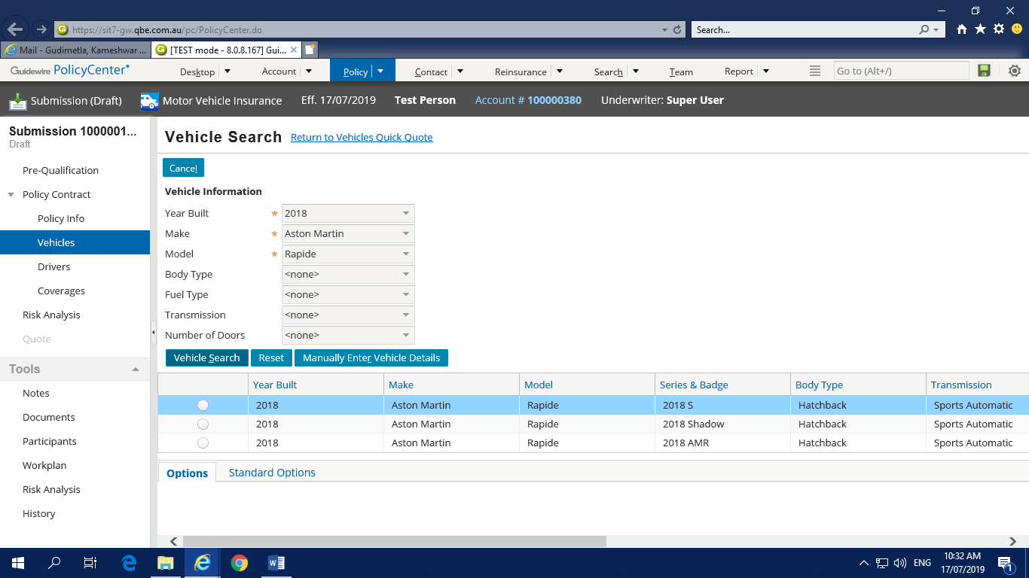

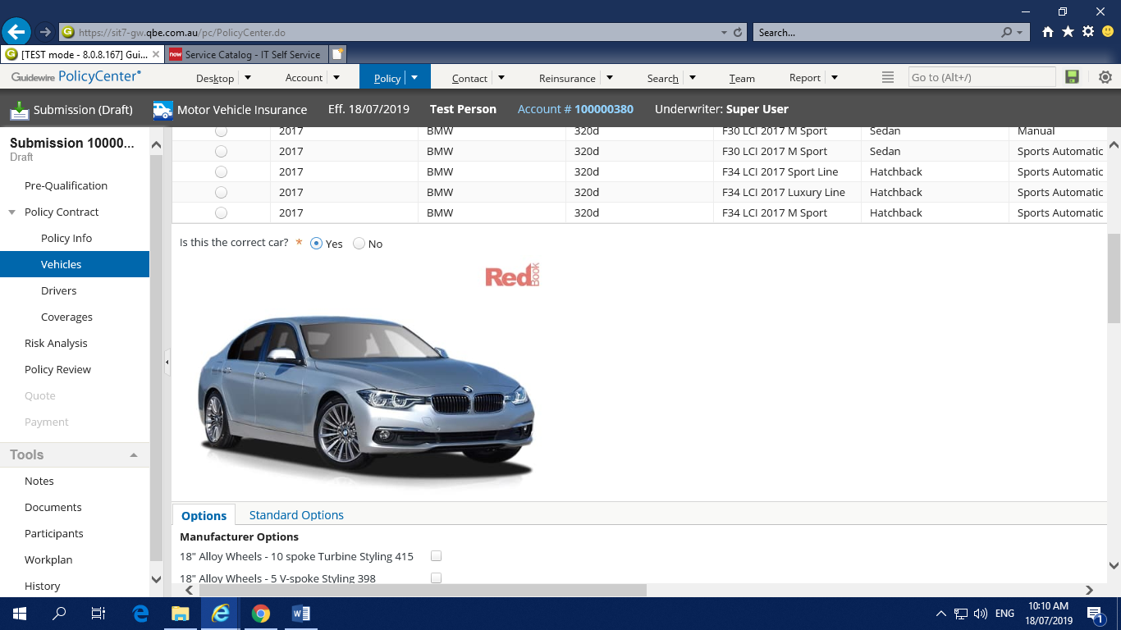

Fill all the mandatory fields in that page and proceed to **Next** button on the top, then we will be navigated to the Drivers Quick Quote page.

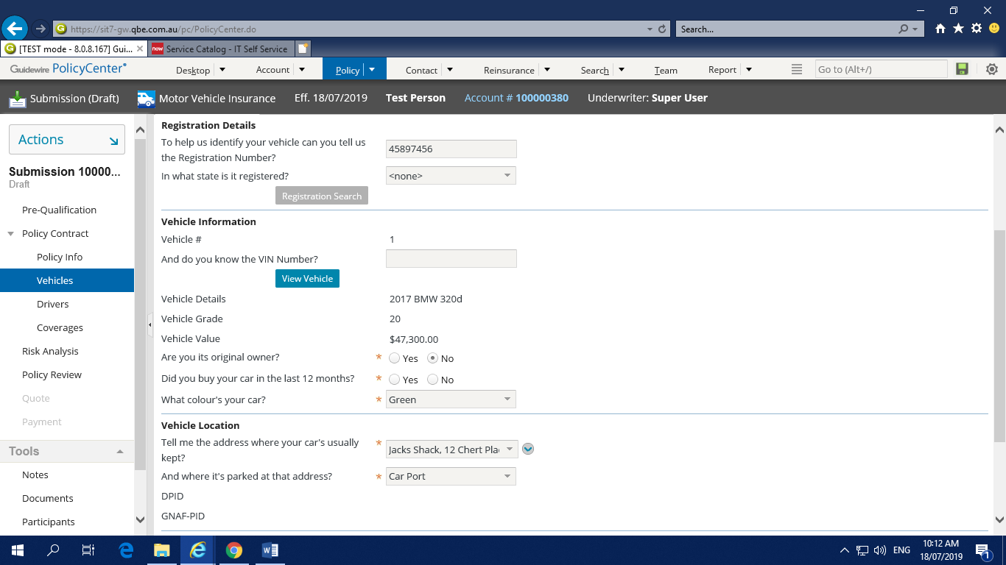

**Step 6:**

Driver’s page will have details about the drivers of the vehicle. Any number of drivers can be added but should have at least one main driver to proceed further. We can add drivers either from address book or Existing driver.

**🡪From Address book**

If we select this option I will navigate to contact search page same as we have done in the contact creation, follow the same procedure as contact creation.

**🡪Existing driver**

In existing driver we get the contact name for whom the policy is being created.

After selecting the driver we get the fields to fill, then fill all the mandatory fields and proceed to **Next** button on the top, then we will be navigated to the Coverages Quick Quote page.

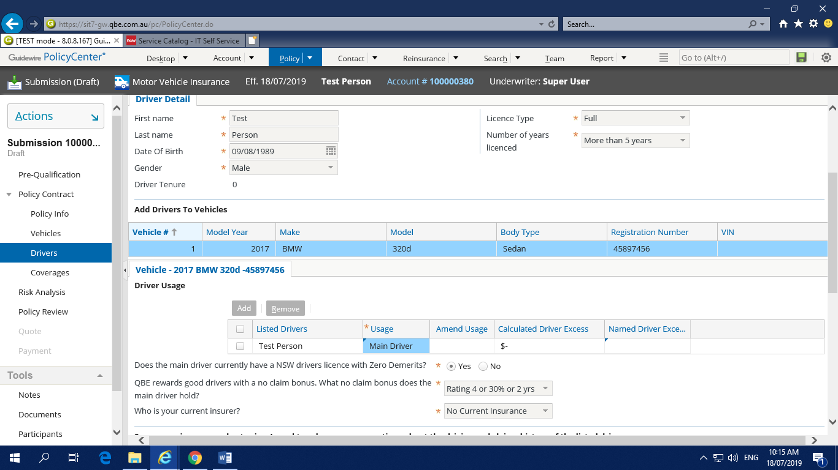

**Step 7:**

Choose an coverage details in coverage page & Select any of the option in the given list. Fill all the mandatory fields and proceed to **Next** button on the top.

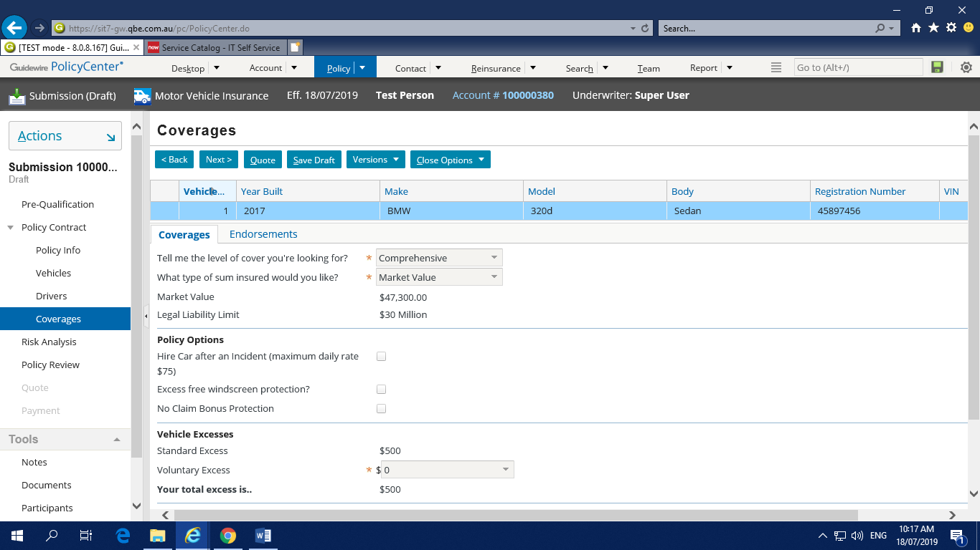

**Step 8:**

Click Next in Risk screen

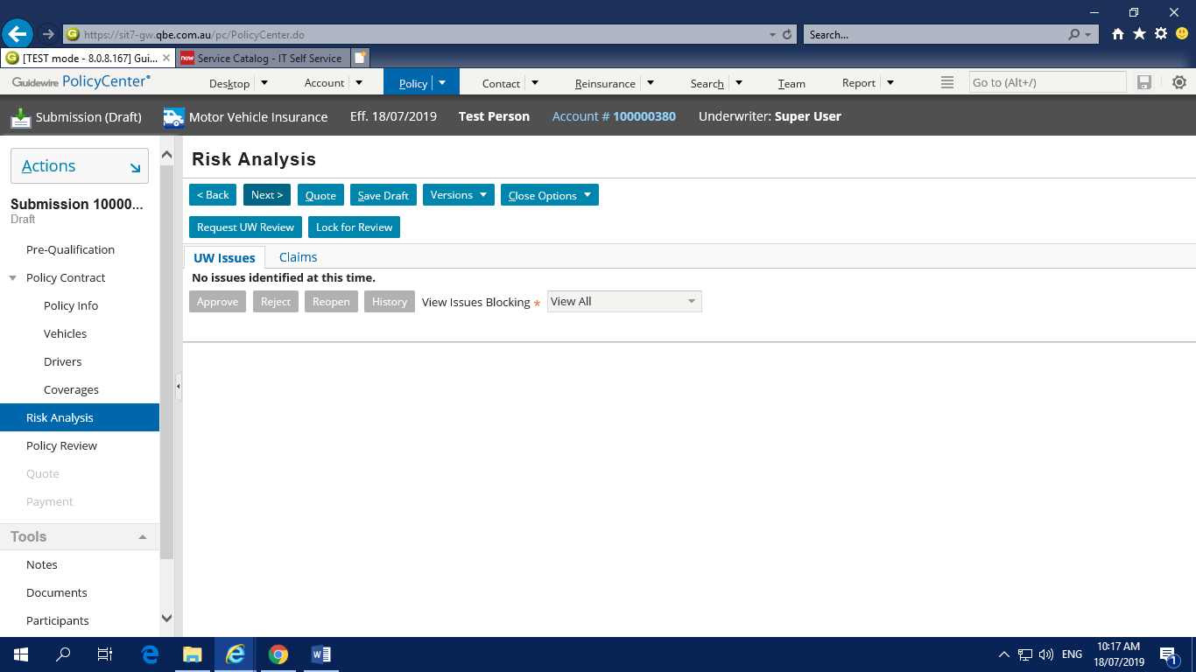

**Step 9:**

Policy Review Screen, will display the summary of the policy for information. If the customer is ok with the policy quote can proceed with policy Issuance.

Click Quote then the policy is gets quoted, the status changes from draft to Quoted

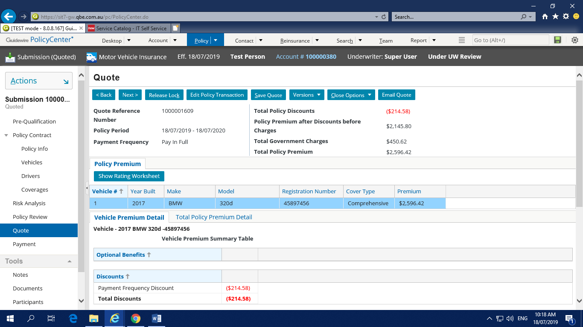Quote page will be displayed with all the entered policy details. Click **Next** button to make a payment

**Step 10:**

We can make a payment with below 3 options,

1. **Pay Later**

If we select this option, issue policy button will be highlighted and the policy will be issued directly without making any payment.

1. **Credit Card**

If u select this option we will get **Capture Credit Card** button, then after it will ask some credit card details and make payment.

Below are the test accounts:

Credit card no: 4111111111111111

CVV: Any three digits

Expiry date: Any date

Bpay:71373

Biller code: 2393

For credit card payments test environment has to be connected to cyber source.

1. **Bank Account.**

If u select this option, we will get **Capture Credit Card** button, then after it will ask some credit card details and make payment.

Below are the test accounts:

BSB: 123-123

BSB: 083-457

Account no: 123456(Any six-digit number)

Account name: Any name

Once the payment is made, policy will issued & will get the policy number & account number

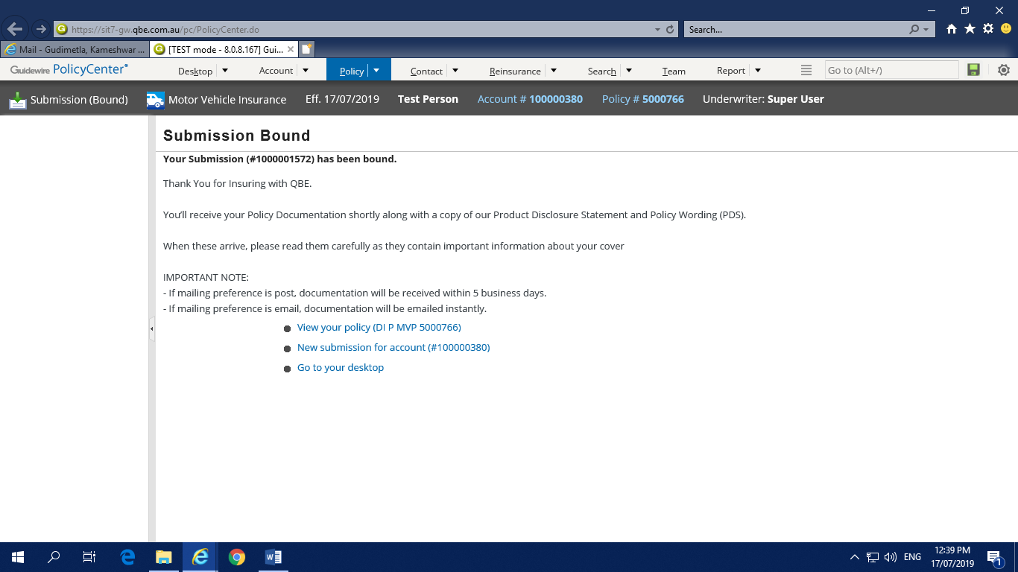

**Document:**

After the policy is issued, documents for the same are created for confirmation. To view the documents click on Documents on the left side menu and can view the documents as shown in the below image.

**3 documents types will get generated as below**

1. Email

2. Message

3. Post

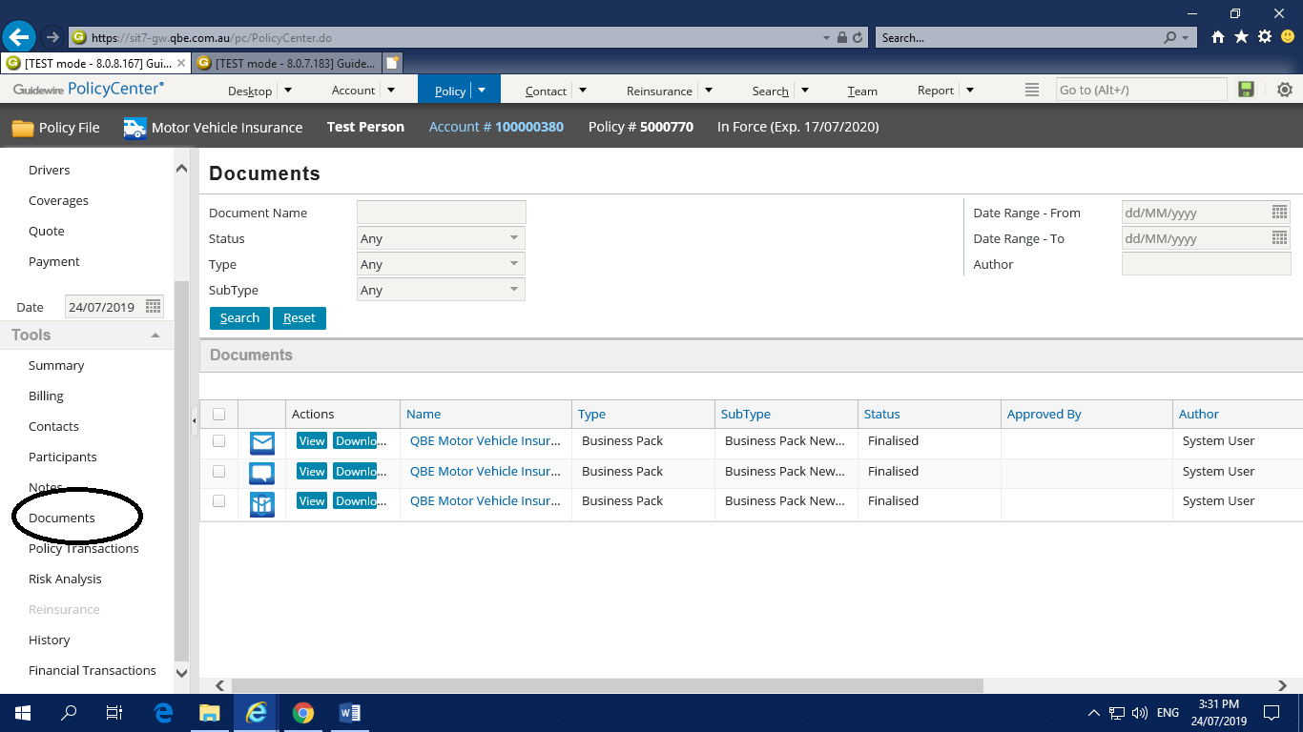

**Change Policy:**

When the user wants to make any changes in the policy like premium or vehicle or driver details, it can be done through **Change Policy** option.

To change policy, go to the required policy and go to **Actions 🡪 Change policy**

The Same screens which ever displayed for policy creations will be displayed & can make changes wherever required & can proceed with Quote option.

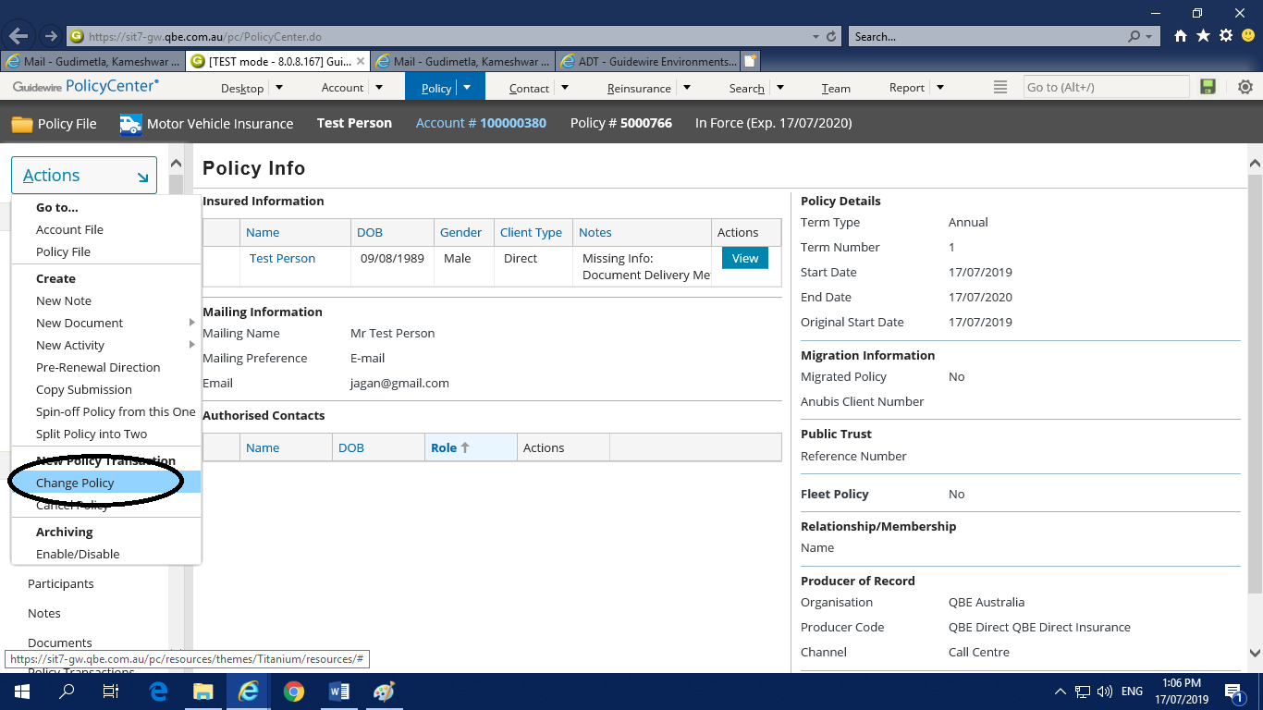

**Cancel Policy:**

If the customer wants to cancel the policy at any cost, it can be done through the option cancel Policy

To cancel policy, go to the required policy and go to **Actions 🡪 Cancel policy**

In the cancel policy we have two types of cancellation

**🡪Flat cancellation**

When the policy is cancelled from the start date to end date ,then it is Flat Cancelation

**🡪Midterm cancellation**

When the policy is cancelled in some term ie one or two months later, it is considered as midterm cancellation

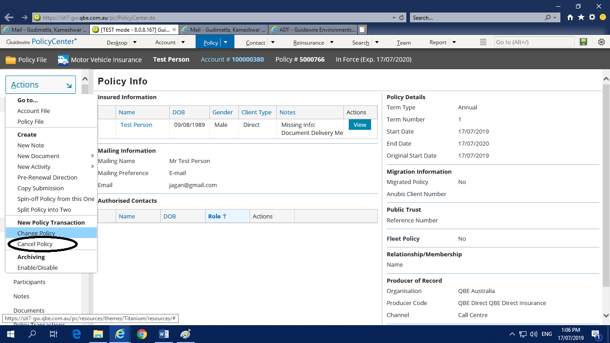

Enter the details to make the cancellation

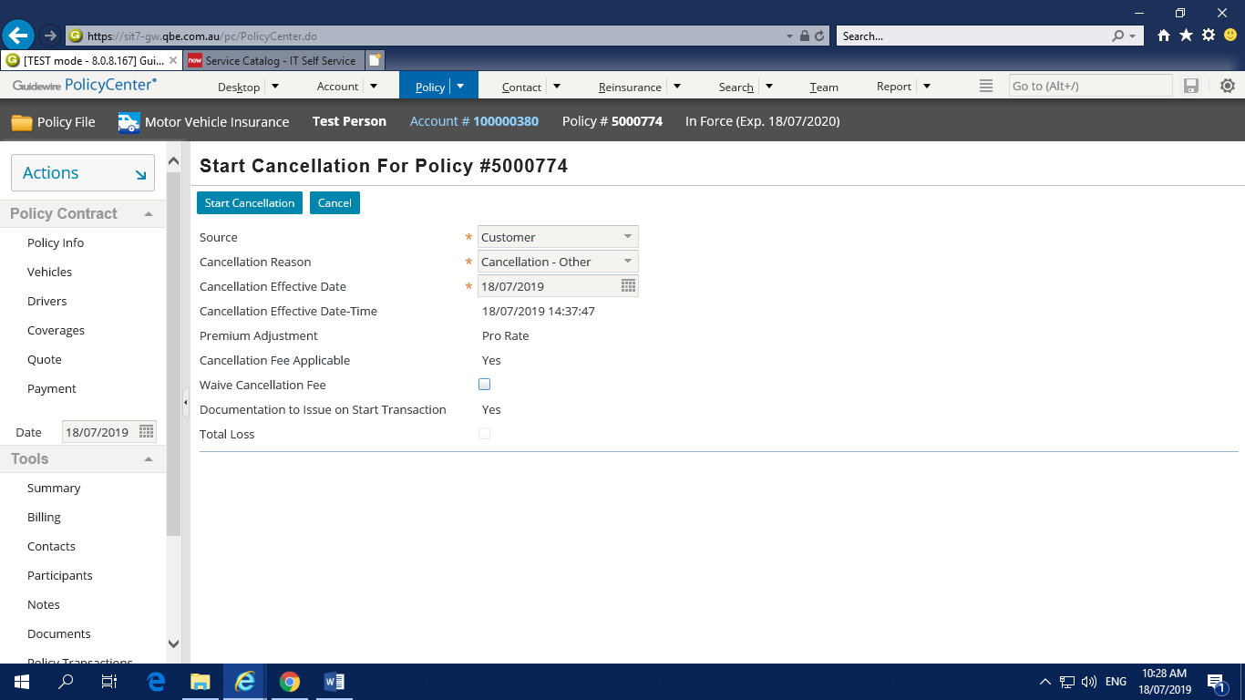

Then we will be navigated to Confirmation page, in that click on Binding options🡪Cancel now

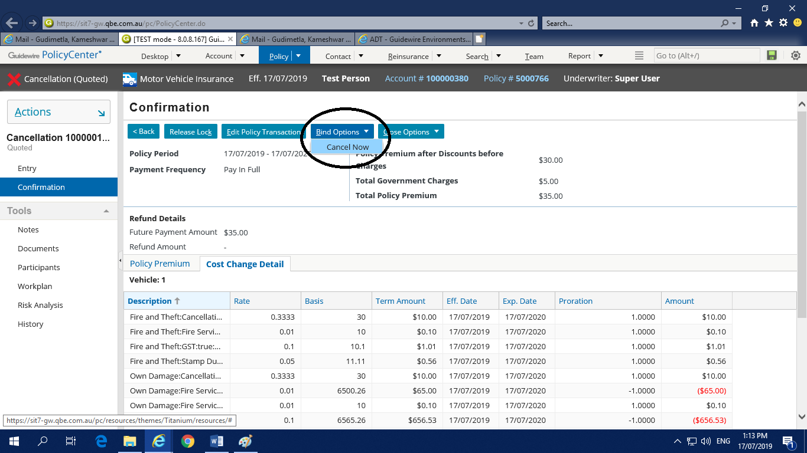

**Reinstatement:**

Reinstatement transaction is done when the customer wants to revoke the policy without any change in the policy.The policy will be revoked same as it is when the policy is cancelled. Once the policy is cancelled will get the option Reinstatement.

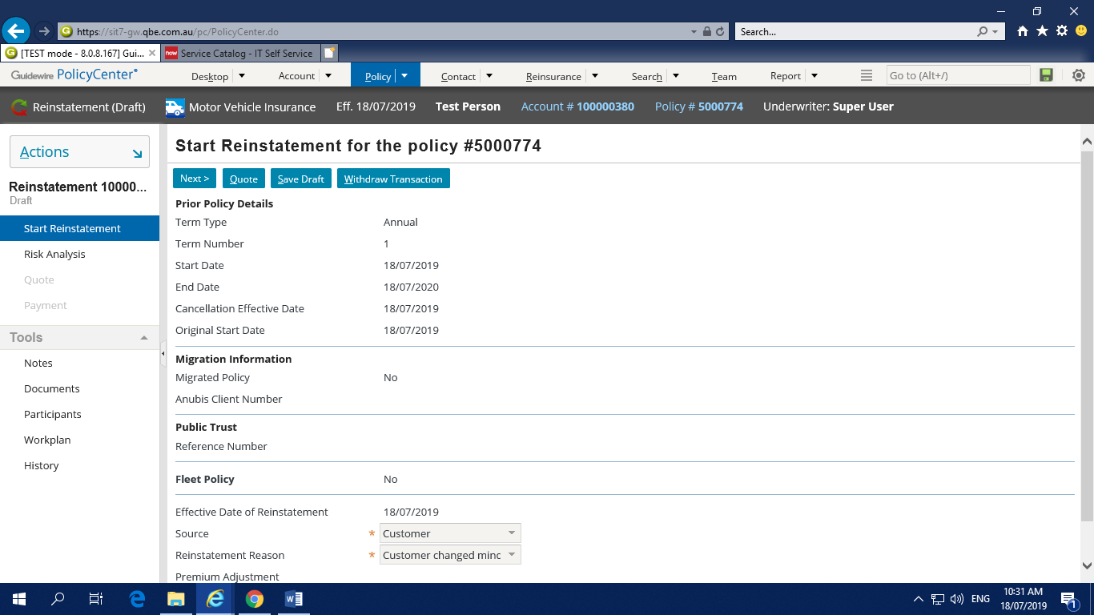To Reinstate policy, go to the required policy and go to **Actions 🡪 policy reinstate**

Fill the mandatory fields and proceed to next

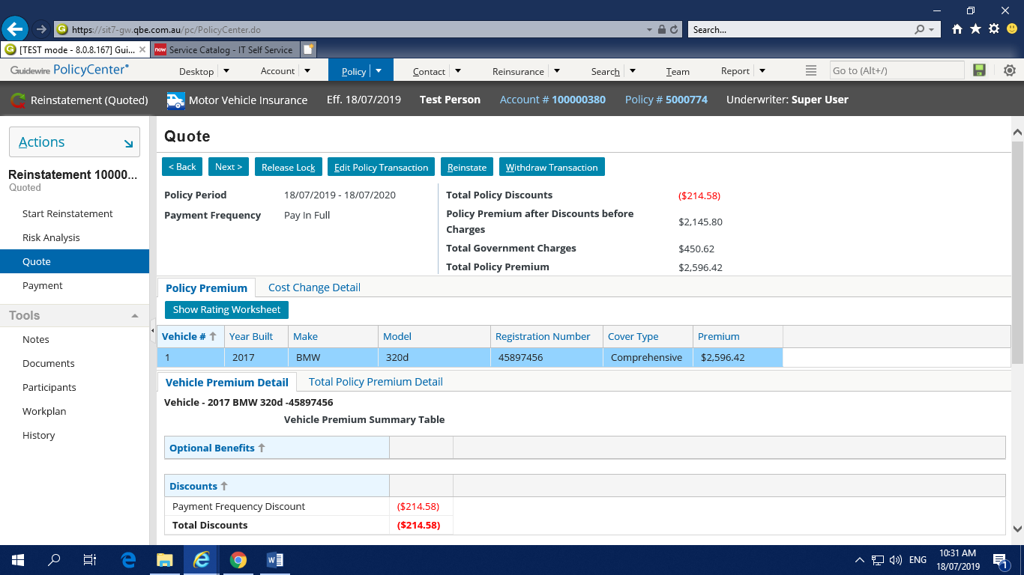

Then the policy will get Quoted and finally Make the payment and Click on Reinstate Button.

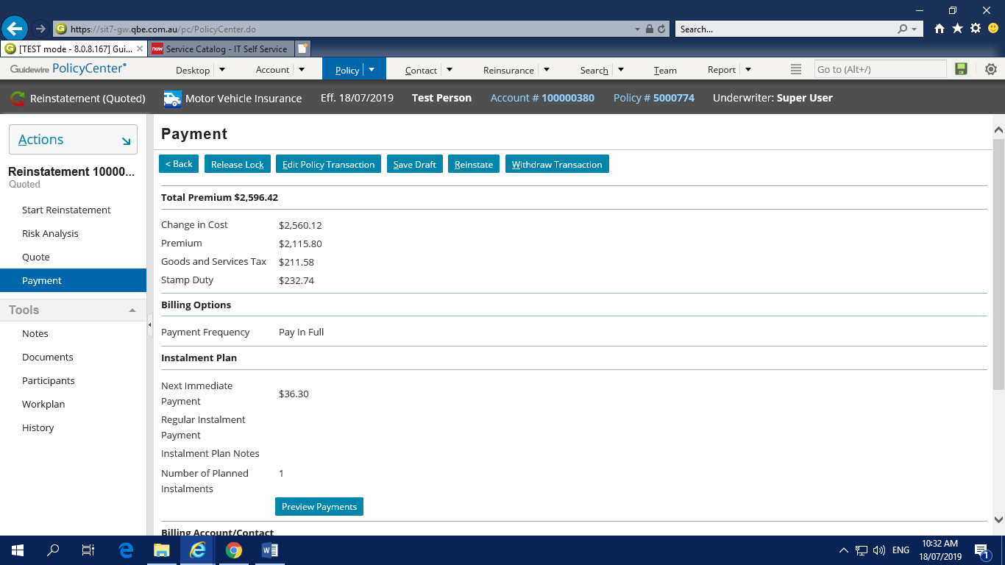

**Rewrite:**

Rewrite transaction is done when the customer wants to revoke the policy with some changes in the policy.

To Rewrite the policy, go to the required policy and go to **Actions 🡪 Rewrite Full Term / Rewrite reminder of term / Rewrite new term**

Below are different types of rewrite option available,

* Rewrite Full Term
* Rewrite Reminder of Term
* Rewrite new term

**Rewrite Full Term**

When we cancel the policy from start date to the end date i.e. after flat cancelation and want to revoke the policy then we will go for Rewrite Full Term.

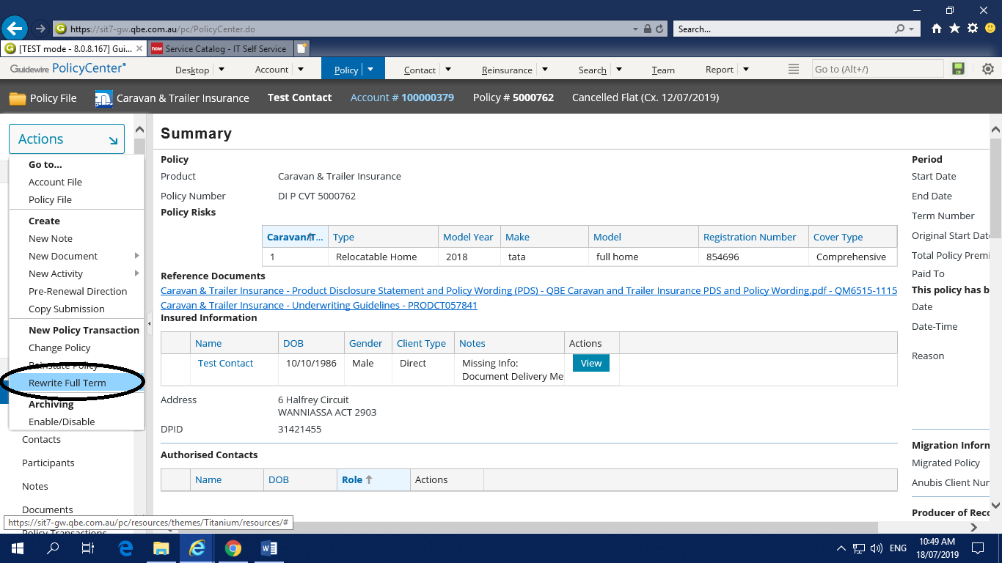

**Rewrite Reminder of Term**

When we cancel the policy from the middle of the term and want to revoke the policy for the cancelled term then we will go for Rewrite reminder of term.

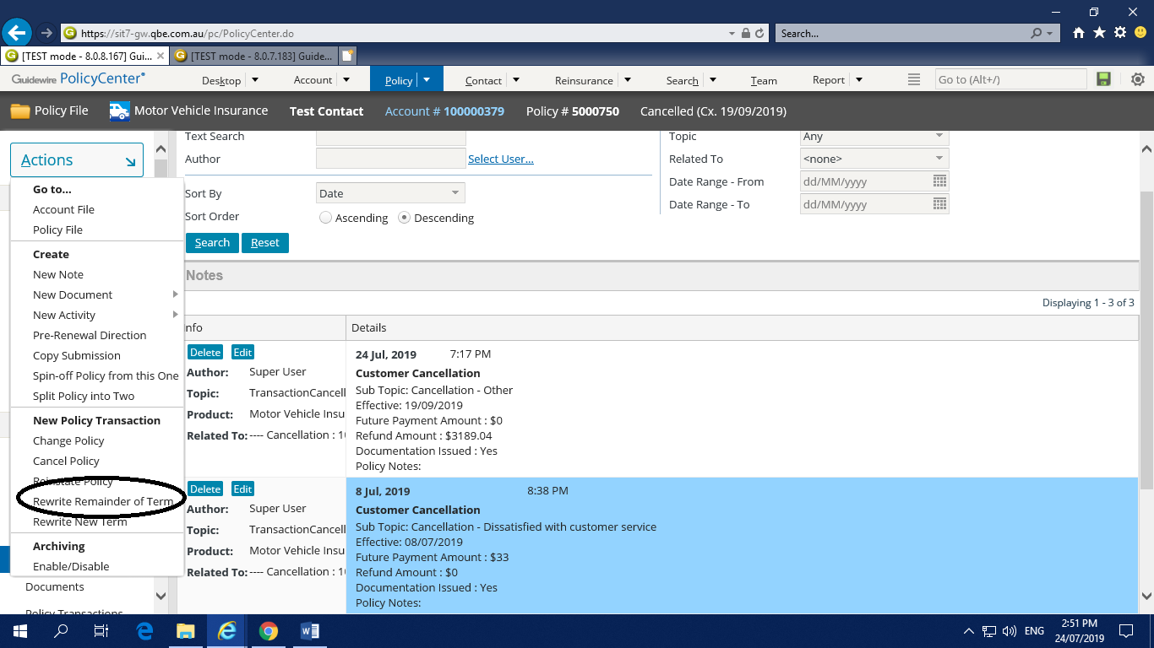

**Rewrite new term**

When we cancel the policy from the middle of the term and want to revoke the policy for the new term then we will go for Rewrite new term.

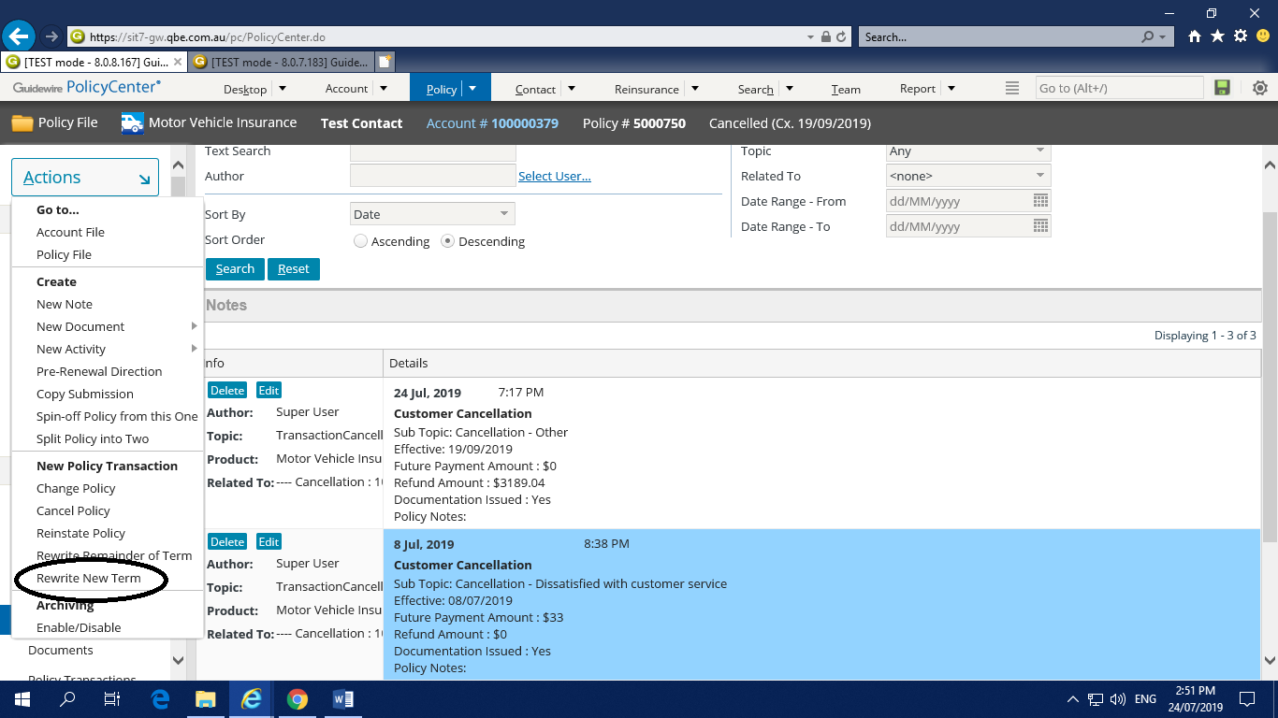

While creating the Rewrite new term we have to select the new term start date in the policy info page and the remaining process is same as followed in the policy creation.

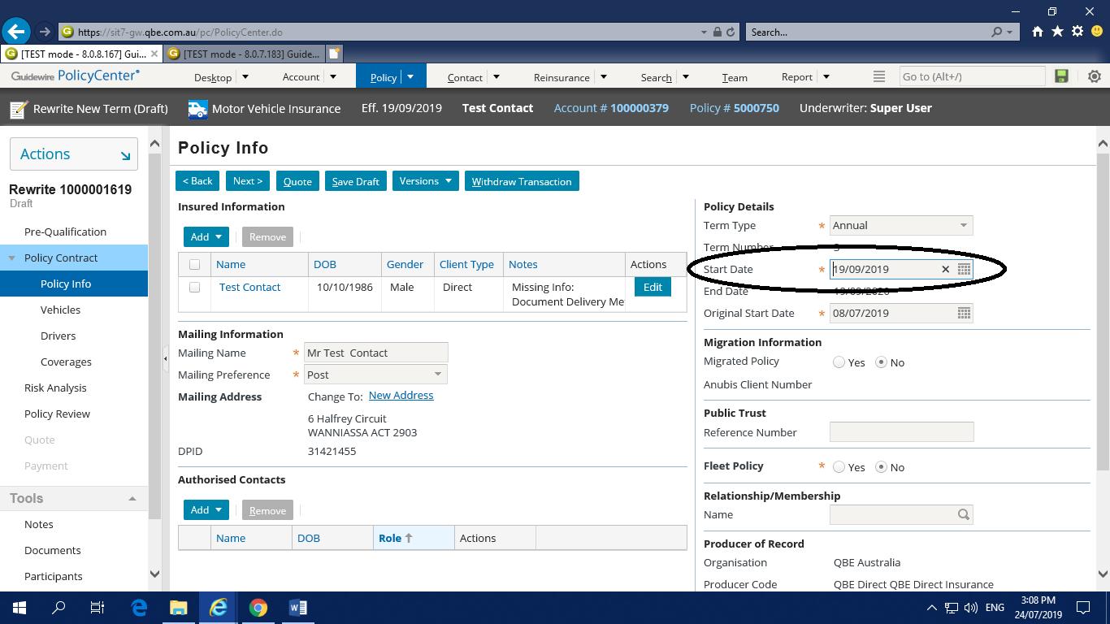

The process to rewrite policy is same as we followed in the policy creation.

**Renew Policy:**

The policy can be renewed from one month before the policy ending date.

To renew the policy go to **Actions🡪Renew**

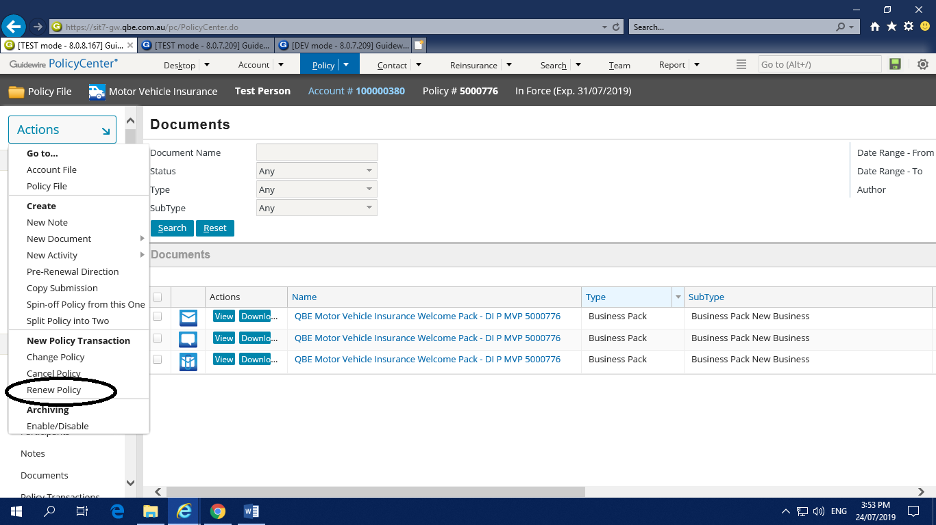

While renewing the previous policy details or we can change if any changes are required. The process is same like that of the policy creation.

To make any changes in the policy details while renewing click on Edit Policy Transaction and follow the same procedure that was followed in policy creation.

